The report for the practical reasons of conflicts in the classroom of adults
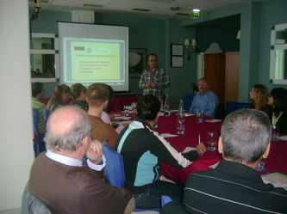
- There are many sources about the conflicts in the classroom and about their solutions.
- During and after the seminar we shared opinions about the conflicts in the classroom.
- The teachers mentioned some problems they have experienced and wanted us to disscuss them with you.
We discussed these problem in the meeting in Spain on 11. October 2013.
Here are the suggestions and ideas of the participants:
- The teachers who teaches both children and adults confuse how to respond to the students. They cannot presume the consequences of their respond.
.The teacher should concentrate on the learners.

- Many courses are funded by the state. The participants do not pay. They spend only TIME but NO MONEY. It is difficult to sustain attendance and motivation especially subjects are getting “difficult”.
.They spend time so the teacher should often remind the value of TIME.

- A)The students attending vocational courses do not want to learn about many things related to the target profession but only “directly” related subjects.
B) “Parent” students. Some students are also mothers or fathers. They think about their children and cannot focus on the lessons.
C) Night courses after “exhausting” workdays.
.All these problems are related to the motivation of the students. The teacher should use methods and materials to take the attention of them.
.Computers, internet and other audiovisual sources are helpful.
.The adult learners have much more life experiences. So allowing them to share their experinces will make the lessons more attractive.

